Date: 23-06-2022

WIND PRESSURE RESISTANCE CERTIFICATE

This is to certify that the Manual Sliding Door - 4 Leaf - RSS - CRM Gate 01 / GATE NO. 09 are designed as per Specific requirements, actual design calculations, Factor of Safety with having a sustainable with suitable capacity of Wind Pressure Resistance of 140 Km/Hr for the ‘Lestech Engineering India Pvt Ltd.’, C-1, MIDC Area, Vile Bhagad, Inside Posco MH Steel, Mangaon, Raigad 402308.
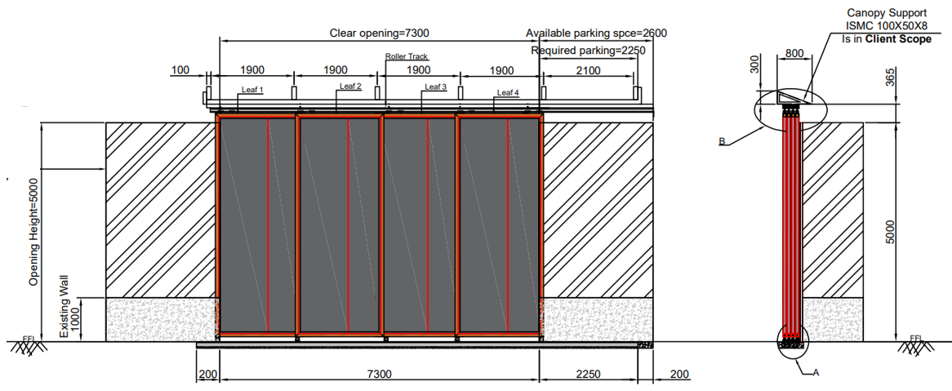

NIHVA Technologies Pvt. Ltd.

Date: 23-06-2022

WIND PRESSURE RESISTANCE CERTIFICATE

This is to certify that the Motorised Rolling Shutter- CRM Gate 02 / GATE NO. 10 are designed as per Specific requirements, actual design calculations, Factor of Safety with having a sustainable with suitable capacity of Wind Pressure Resistance of 140 Km/Hr for the ‘Lestech Engineering India Pvt Ltd.’, C-1, MIDC Area, Vile Bhagad, Inside Posco MH Steel, Mangaon, Raigad 402308.
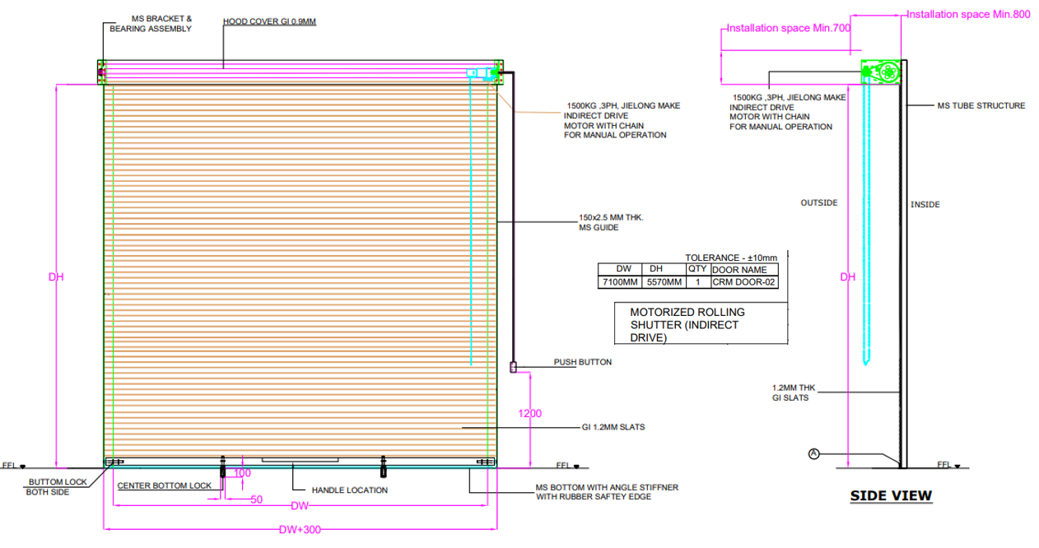

NIHVA Technologies Pvt. Ltd.

Date: 23-06-2022

WIND PRESSURE RESISTANCE CERTIFICATE

This is to certify that the Manual Sliding Door - 3 Leaf - RSS - CRM Gate 03 / GATE NO. 11 are designed as per Specific requirements, actual design calculations, Factor of Safety with having a sustainable with suitable capacity of Wind Pressure Resistance of 140 Km/Hr for the ‘Lestech Engineering India Pvt Ltd.’, C-1, MIDC Area, Vile Bhagad, Inside Posco MH Steel, Mangaon, Raigad 402308.
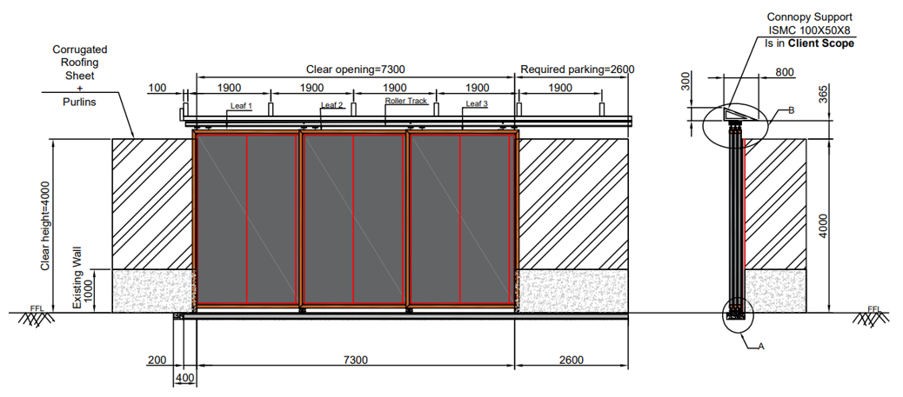

NIHVA Technologies Pvt. Ltd.

Date: 23-06-2022

WIND PRESSURE RESISTANCE CERTIFICATE

This is to certify that the Manual Sliding Door - 3 Leaf - RSS - CRM Gate 04 / GATE NO. 13 are designed as per Specific requirements, actual design calculations, Factor of Safety with having a sustainable with suitable capacity of Wind Pressure Resistance of 140 Km/Hr for the ‘Lestech Engineering India Pvt Ltd.’, C-1, MIDC Area, Vile Bhagad, Inside Posco MH Steel, Mangaon, Raigad 402308.
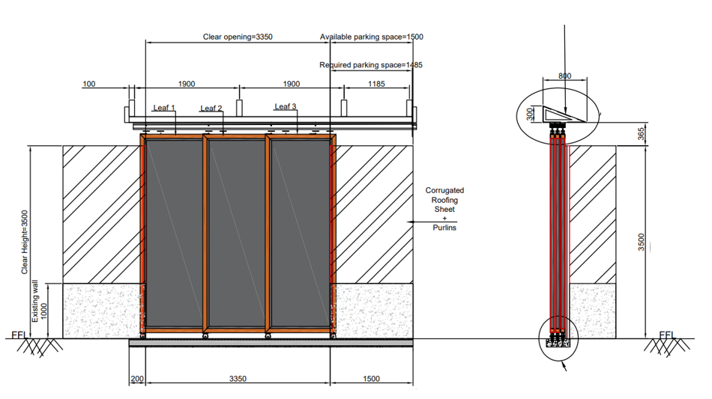

NIHVA Technologies Pvt. Ltd.

Date: 23-06-2022

WIND PRESSURE RESISTANCE CERTIFICATE

This is to certify that the Manual Sliding Door - 1 Leaf - LSS - CRM Gate 05 / GATE NO. 14 are designed as per Specific requirements, actual design calculations, Factor of Safety with having a sustainable with suitable capacity of Wind Pressure Resistance of 140 Km/Hr for the ‘Lestech Engineering India Pvt Ltd.’, C-1, MIDC Area, Vile Bhagad, Inside Posco MH Steel, Mangaon, Raigad 402308.
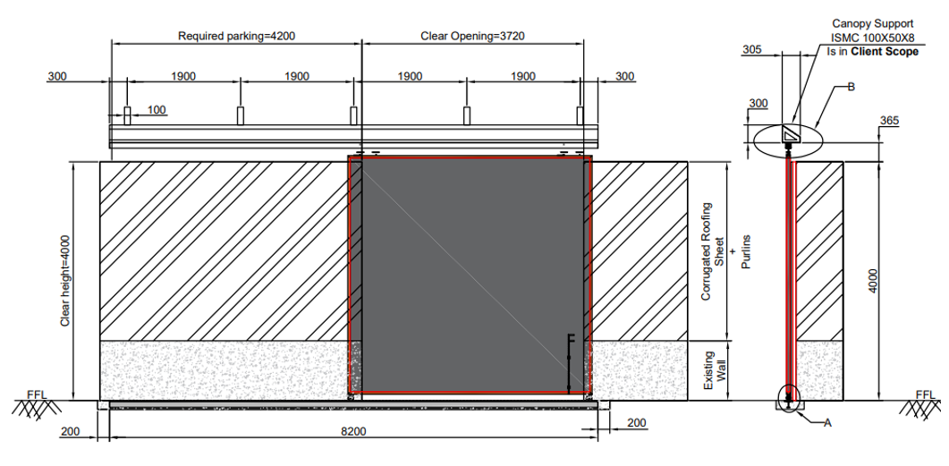

NIHVA Technologies Pvt. Ltd.

Date: 23-06-2022

WIND PRESSURE RESISTANCE CERTIFICATE

This is to certify that the Manual Sliding Door - 4 Leaf - BSS - CRM Gate 06 / GATE NO. 17 are designed as per Specific requirements, actual design calculations, Factor of Safety with having a sustainable with suitable capacity of Wind Pressure Resistance of 140 Km/Hr for the ‘Lestech Engineering India Pvt Ltd.’, C-1, MIDC Area, Vile Bhagad, Inside Posco MH Steel, Mangaon, Raigad 402308.
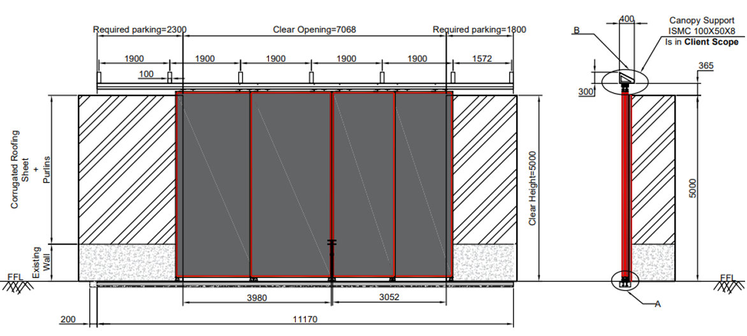

NIHVA Technologies Pvt. Ltd.

Date: 23-06-2022

WIND PRESSURE RESISTANCE CERTIFICATE

This is to certify that the Manual Sliding Door: 2 Leaf - BSS - CRM Gate 07 / GATE NO. 19 are designed as per Specific requirements, actual design calculations, Factor of Safety with having a sustainable with suitable capacity of Wind Pressure Resistance of 140 Km/Hr for the ‘Lestech Engineering India Pvt Ltd.’, C-1, MIDC Area, Vile Bhagad, Inside Posco MH Steel, Mangaon, Raigad 402308.
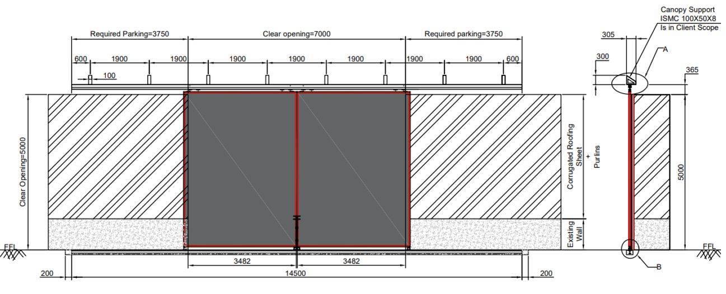

NIHVA Technologies Pvt. Ltd.

Date: 23-06-2022

WIND PRESSURE RESISTANCE CERTIFICATE

This is to certify that the Swing Door: Outside Opening-CRM Gate 08 / GATE NO. 20 are designed as per Specific requirements, actual design calculations, Factor of Safety with having a sustainable with suitable capacity of Wind Pressure Resistance of 140 Km/Hr for the ‘Lestech Engineering India Pvt Ltd.’, C-1, MIDC Area, Vile Bhagad, Inside Posco MH Steel, Mangaon, Raigad 402308.
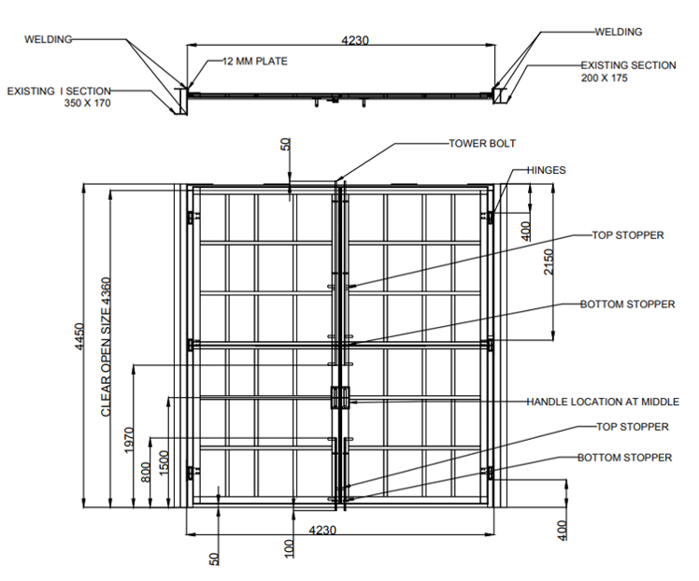
NIHVA Technologies Pvt. Ltd.

Date: 23-06-2022

WIND PRESSURE RESISTANCE CERTIFICATE

This is to certify that the Manual Sliding Door: 2 Leaf - RSS - CRM Gate 09 / GATE NO. 21 are designed as per Specific requirements, actual design calculations, Factor of Safety with having a sustainable with suitable capacity of Wind Pressure Resistance of 140 Km/Hr for the ‘Lestech Engineering India Pvt Ltd.’, C-1, MIDC Area, Vile Bhagad, Inside Posco MH Steel, Mangaon, Raigad 402308.
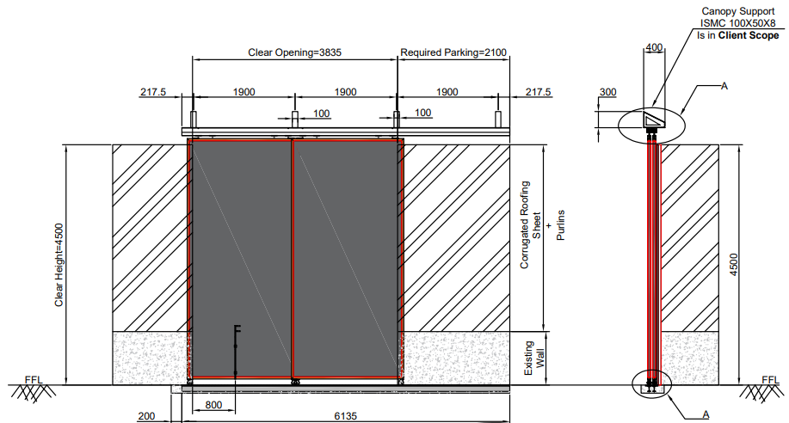

NIHVA Technologies Pvt. Ltd.

Date: 23-06-2022

WIND PRESSURE RESISTANCE CERTIFICATE

This is to certify that the Manual Sliding Door: 4 Leaf - BSS - CRM Gate 10 / GATE NO. 24 are designed as per Specific requirements, actual design calculations, Factor of Safety with having a sustainable with suitable capacity of Wind Pressure Resistance of 140 Km/Hr for the ‘Lestech Engineering India Pvt Ltd.’, C-1, MIDC Area, Vile Bhagad, Inside Posco MH Steel, Mangaon, Raigad 402308.
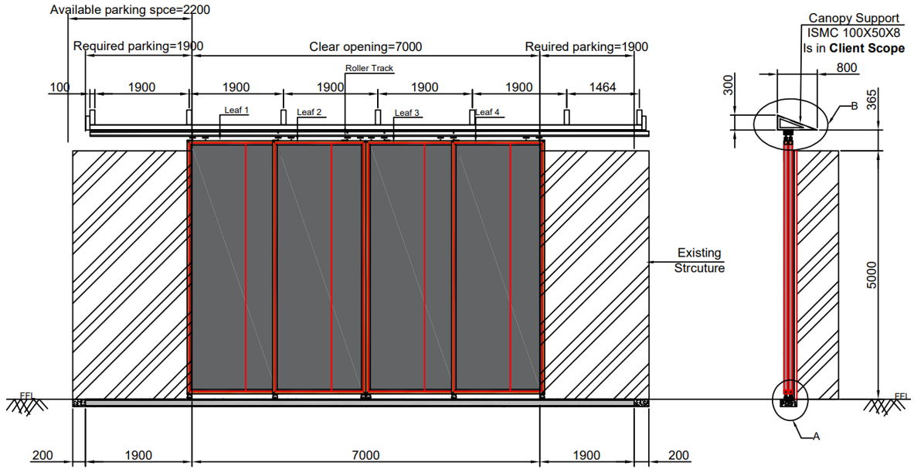

NIHVA Technologies Pvt. Ltd.

Date: 23-06-2022

WIND PRESSURE RESISTANCE CERTIFICATE

This is to certify that the Manual Sliding Door - 3 Leaf - RSS - CRM Gate 11 / GATE NO. 25 are designed as per Specific requirements, actual design calculations, Factor of Safety with having a sustainable with suitable capacity of Wind Pressure Resistance of 140 Km/Hr for the ‘Lestech Engineering India Pvt Ltd.’, C-1, MIDC Area, Vile Bhagad, Inside Posco MH Steel, Mangaon, Raigad 402308.
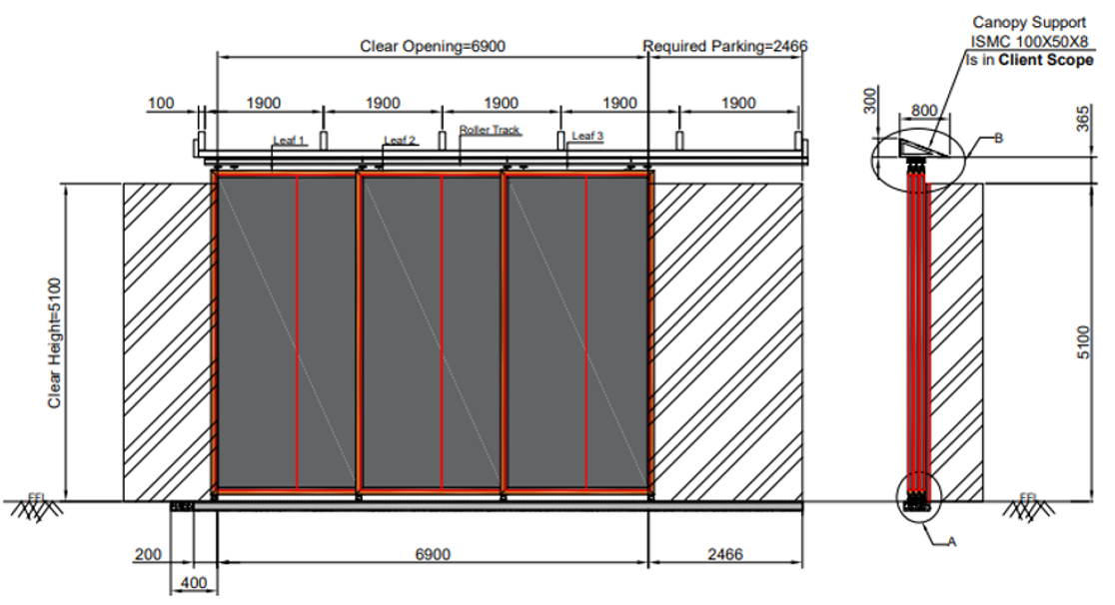

NIHVA Technologies Pvt. Ltd.

Date: 23-06-2022

WIND PRESSURE RESISTANCE CERTIFICATE

This is to certify that the Manual Sliding Door - 2 Leaf - LSS - CRM Gate 12 / GATE NO. 26 are designed as per Specific requirements, actual design calculations, Factor of Safety with having a sustainable with suitable capacity of Wind Pressure Resistance of 140 Km/Hr for the ‘Lestech Engineering India Pvt Ltd.’, C-1, MIDC Area, Vile Bhagad, Inside Posco MH Steel, Mangaon, Raigad 402308.
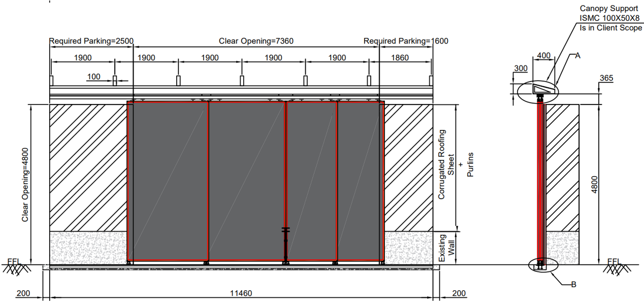

NIHVA Technologies Pvt. Ltd.

Date: 23-06-2022

WIND PRESSURE RESISTANCE CERTIFICATE

This is to certify that the Manual Sliding Door: 4 Leaf - BSS - CRM Gate 13 / GATE NO. 27 are designed as per Specific requirements, actual design calculations, Factor of Safety with having a sustainable with suitable capacity of Wind Pressure Resistance of 140 Km/Hr for the ‘Lestech Engineering India Pvt Ltd.’, C-1, MIDC Area, Vile Bhagad, Inside Posco MH Steel, Mangaon, Raigad 402308.

NIHVA Technologies Pvt. Ltd.

Date: 23-06-2022

WIND PRESSURE RESISTANCE CERTIFICATE

This is to certify that the Motorised Rolling Shutter- CRM Gate 14 / GATE NO. 18 are designed as per Specific requirements, actual design calculations, Factor of Safety with having a sustainable with suitable capacity of Wind Pressure Resistance of 140 Km/Hr for the ‘Lestech Engineering India Pvt Ltd.’, C-1, MIDC Area, Vile Bhagad, Inside Posco MH Steel, Mangaon, Raigad 402308.
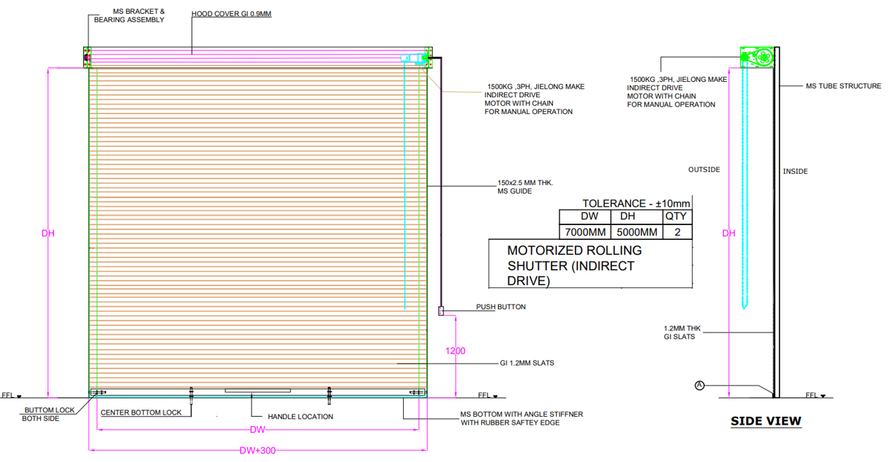

NIHVA Technologies Pvt. Ltd.
Date: 23-06-2022

WIND PRESSURE RESISTANCE CERTIFICATE

This is to certify that the Motorised Rolling Shutter- ACL Gate 01 / GATE NO. 9 are designed as per Specific requirements, actual design calculations, Factor of Safety with having a sustainable with suitable capacity of Wind Pressure Resistance of 140 Km/Hr for the ‘Lestech Engineering India Pvt Ltd.’, C-1, MIDC Area, Vile Bhagad, Inside Posco MH Steel, Mangaon, Raigad 402308.

NIHVA Technologies Pvt. Ltd.

